
SHIRE HIGHLANDS EDUCATION DIVISION
2026 MALAWI SCHOOL CERTIFICATE OF EDUCATION MOCK
EXAMINATION

WOODWORK
Paper I
Theory and Design
MARKING SCHEME

Section A (30 marks)
Candidates were required to answer all questions from this section.

1. a. What is the difference between case hardening from a check in timber?

Case hardening is a defect that occurs during kiln seasoning
where the exterior surface of timber dries out and becomes hard before the interior is dried¹ while a check is a separation of wood along the grain usually in the direction of the rays. ¹

b. (i) Name the type of timber defects A and B.
A Star shake ¹
B ring or cup shake ¹

(ii) Give the cause of timber defect B.

Strong wings straining the tree while it is growing or the shock sustained by the tree when it is felled ¹

c. State one disadvantage of preserving timber by spraying or brushing.
Low penetration of preservatives to wood cells ¹
2. a. Define the following terms as used in woodwork:
(i) fixed assets
Remain for long period of time ¹

(ii) current assets
Are constantly used and replaced during everyday business¹

b. Give one example of each of the terms in 2 (a).
(i) fixed assets
Land, buildings, heavy machines, vehicles ^{Any} ¹

(ii) current assets
Raw materials, products and cash ^{Any} ¹

c. (i) Why is motivation of workers important?

It drives workers to work more and keep them for long time without
losing them to other employers¹

(ii) Give one advantage of preparing a cutting list in furniture production.
Prevent underbuying or over-purchasing input materials/helps to cut required dimensions and joints for projects/ helps to calculate costs and prepare budget ^{Any} ¹

3. a. (i) Define shearing strength as a mechanical property of timber.
Ability of wood to resist loads which tear the fibres causing them to slide pass each other ¹

(ii) Give one example in woodwork where shearing strength could be applied.
Wood work joints such as mortise and tenon ¹

b. (i) Identify forces operating in beams A and B.
A Compression force ¹
B Tension force ¹
(ii) Using arrows, indicate on the diagram the direction of forces acting in
beam B.

Candidates must indicate arrows acting in opposite directions along the beam to show that tension forces act outwardly from each other ¹as shown

(iii) State how presence of knots in beam B could weaken its stability.
Tensile strength will be reduced hence weakening its mechanical stability ¹

4. a. Describe any two practices that should be done to prolong life of hand tools in
the workshop.
Using the right tools for the job/avoid heaping different or many tools at one place, as cutting edges get damaged/tools should be returned to the stores and placed in their proper locations/cutting tools must be sharpened to enhance perfect work ^{Any} ²
b. Define the following processes carried out on a dimension circular saw:
- Ripping
Cutting timber along the length of its grains or fibres ¹
(ii) chamfering
Process of planning off 45° amount of material from the edge of a piece of timber ¹/removing sharp corners on a piece of timber

c. Differentiate the use of each of the following special curve-cutting saws:

- coping saw
Used for cutting internal and external curves in thinner materials such as plywood ¹

- bow saw
Used for cutting internal and external larger curves in thicker or heavy timber ¹

5. a State one advantage of portable power tools over machine tools.
Power tools do not require floor or bench space for installation and use ¹
b. (i)Give the name and function of the machine shown in Figure 3.
Name Press drill ¹
Function Drilling holes/sander/mortising moulding ^{Any} ¹

- Name parts labelled X and Y
X Operating handles ¹
Y Chuck ¹

- State any one safety precautions to be observed when working on the machine shown in Figure 3.

Secure loose clothing/wear goggles/lock the table firmly before starting drilling/stop the machine when adjusting speed/use correct speed for each operation/use the guards always ^{Any} ¹

Section B (30 marks)
Candidates were required to select and answer only two questions from this section.
6. a. Name the type of hinges labelled A and B
A: Butt hinges
B: Back flap hinges (2 marks)
b. Give any one use of hinges labelled C
Used for external doors such as garage doors, gates, workshop doors (1 mark)
c. Give any two common locks that are used on doors and windows of houses
rim lock
mortise locks and night latches ( 2 marks)
d. Define the following terms as used in roofing
i. Rise : vertical height of the ridge above the wall plate
ii span : the horizontal distance between the outer edges of the wall plates
(2 marks)
e. With aid of sketches, describe how a mortise lock can be fitted into a door.
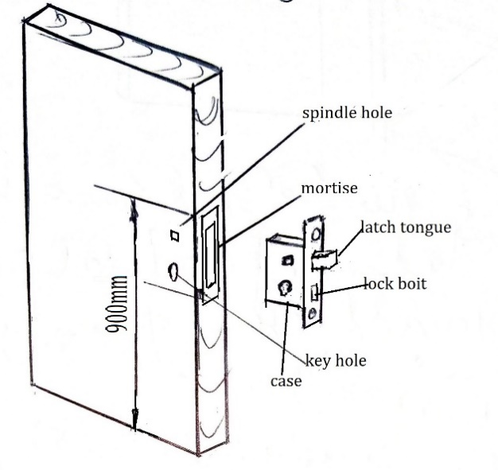
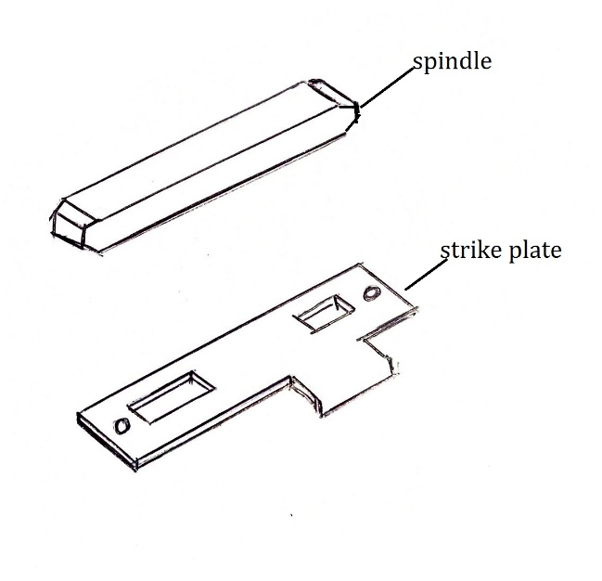
sketches (3marks)
- Mark the position of spindle hole, and key hole on both sides of the door, see the sketch,
- Bore a series of holes for the mortise, remove the waste.
- Bore the key and spindle holes from one side of the door at a time.
- Insert the mortise lock into the mortise, trace shape of face plate of the mortise lock. Remove the lock, make a recess for the face plate, secure it with countersunk screws through face plate holes.
e)Insert spindle into the spindle hole, fix handles and screw them, try the key if it can open and close.

(5marks)
7. a. A freshly cut piece of timber weighs 31.5g. When thoroughly dried in an oven,
it weighs 23.6g. Work out percentage moisture content of the timber.
Moisture content % = Weight _{wet} - Weight _{dry} / Weight _{dry} x 100 ¹
= (31.5 - 23.6)g / 23.6g x 100 ¹=7.9g/23.6g x 100
= 33.5% ¹
b. How does unseasoned timber affect the following:

(i) transportation of timber
Unseasoned timber is heavy hence expensive to transport and difficult to handle ¹

(ii) finishes and adhesives
Wet surfaces of unseasoned timber cannot take finishes and adhesives as they are incompatible with finishes and adhesives ¹

(iii) nails and screws used as fasteners
Unseasoned timber increases risk of corrosion as most nails and screws are made of ferrous metals ¹

c. (i) Why is primer coat necessary in finishing woodwork products?
Primer coat provides a bond for subsequent finishes ¹
(ii) Write down three steps to be followed when applying initial three coats of varnish to a piece of wood product.

Apply the first coat along the grain ¹
Apply the second coat across the grain ¹
Apply the last coat along the grain again ¹
d. State any three characteristics of polyvinyl acetate (PVA) glue.
Non-toxic and non-staining.
Resistant to fungi.
Low heat resistance.
Excellent gap filling qualities ^{Any 3}

e. Differentiate the functions of ‘catches’ and ‘stays’ when fitted to lids of boxes.

Catches are spring-like or have magnates that keep lids in position after closing ¹
Stays are long metals fixed between lids and boxes, so that the lids are supported when opened. ¹

8. a. State how you would use the following tools on the piece of timber:

(i) try square
Square with the edges and mark given dimensions 60mm and 100mm ¹

(ii) marking gauge
Gauge/mark 25mm round the piece ¹
(iii) bevel square
Adjust the bevel from corner to 60mm and mark the bevel line ¹
(iv) cross-cut saw
Cut across the grain along the bevel line ¹
b. Mention any three ways of reinforcing woodwork joints.
Using nails
Using glue
Using dowels ³

c. (i) State any two factors to consider when selecting upholstery materials

Fabric durability, product style, fabric colour, maintenability, smell ¹
(any two 1mark each))
(ii) Give any three advantages and disadvantages of a flat roof.
Advantages:
- Flat roof allows greater flexibility of house design and lay-out.
- It looks beautiful and most attractive when used in suitable surrounding.
- Flat roof is more stable against high winds,
- construction and maintenance is easier (any³)

Disadvantages:
^{Any 3}

- The span (the horizontal distance between two points of support, like the outer walls or load-bearing walls) of flat roof is restricted, unless intermediate columns are introduced. Pitched roofs can be used over large spans without any intermediate column.
- The self-weight of flat roof is very high demanding use of heavy sized beams, columns, foundations and other structural members.
- They are unsuitable at the places of heavy rainfall.
- They are highly unsuitable to hilly areas or other areas where there is heavy snowfall

SECTION C (40 MARKS)
Answer both questions in this section on an A3 paper provided.
Use the following information to answer questions 9 and 10.
Students have a challenge of safe keeping of hand tools in the workshop.
Design a HAND TOOL SHELF that can safely keep hand tools. The design should fulfil the following:
- It must be movable.
- One compartment be lockable.
- Strong, Attractive and durable.
- 1200mm x 800 mm x 350 mm in size.
9. a. Make outlined sketches to show your two ideas of the HAND TOOLSHELF. (10marks)

b. Select the best design and produce its cutting list (5marks)
- materials.
- Sizes.
- types of finish.
- number of parts required.
c. Draw an ISOMETRIC EXPLODED VIEW to a suitable scale, of any one joint to be used in your construction. (5marks)

10. Using the best design chosen, draw the following views to a suitable scale in either first angle or third angle orthographic projection:
a. A front elevation of the HAND TOOL SHELF. (8marks)
b. An end elevation from the left view. (6marks)
c. Insert three main dimensions. (3marks)
d. Indicate the
- scale used. (1mark)
- symbol of projection used (2marks)

(marks to be awarded depending on how best the areas in question have been done following the marks allocated)

END OF MARKING SCHEME

